(NOTE: THIS IS JUST A TEMPLATE, you are to use as reference then INCLUDE this in Appendix A.1 of the SRS)

Requirements - Use case modeling

1. Identifying actors

Procedure

Your mission is to take the existing project documentation (SE Team Project with Line Numbers.doc) and use this to identify the actors that interact with the TEAM4OIES.

When identifying actors, consider the following questions:

• Who or what uses the system?
• What roles do they play in the interaction?
• Who installs the system?
• Who starts and shuts down the system?
• Who maintains the system?
• What other systems use this system?
• Who gets and provides information to the system?
• Does anything happen at a fixed time?

Create a table as shown below, and for each actor, write down the actor name and a short paragraph describing the semantics of the actor:

TABLE: Actors
Actor # | Actor Name | Brief semantics
Actor1 | TheActorName | The brief semantics of the actor

2. Identifying use cases

Procedure

Take the existing project documentation (SE Team Project with Line Numbers.doc) and your list of actors from Table 1 and use this to identify the use cases of the TEAM4OIES.

When identifying use cases, consider the following questions:
• What functions will a specific actor want from the system?
• Does the system store and retrieve information? If so, which actors trigger this behavior?
• Are any actors notified when the system changes state?
• Are there any external events that affect the system? What notifies the system about those events?

Create a table as shown below and for each use case, write down the use case name and a short paragraph describing the brief semantics of the use case:

TABLE 2: LABELED USE CASES
Use case Number | Use case name | Brief Semantics | Line Numbers
UC1 | TheUseCaseName | The semantics of the use case | xxx - xxx

3. Creating use case diagrams

Procedure

Use the UML notation for use cases and actors to create a use case diagram that shows the relationships between the use cases UC1 and ACTORS that you have identified above.

Figure below is an example of a UML Use Case Diagram:

FIGURE 1: LABELED UML USE CASES DIAGRAM

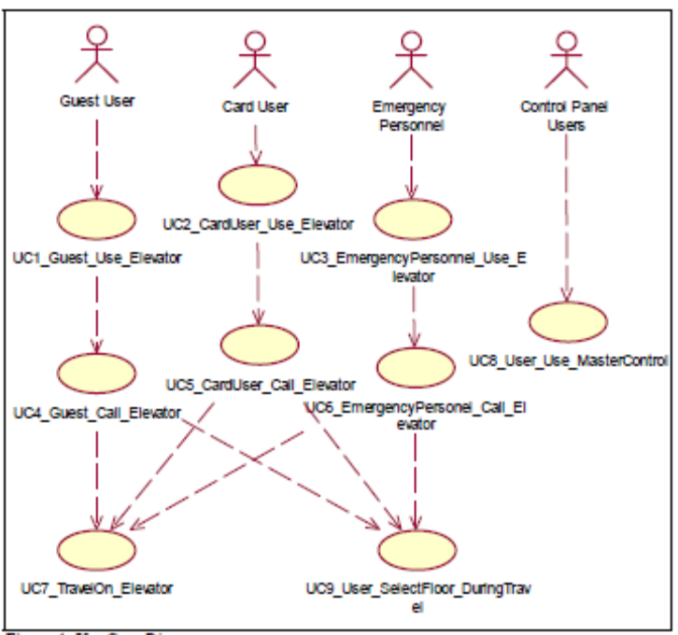

4. Detailing the Use Cases (Use Case Scenarios)

Procedure

Take at least three of your use cases and create for each a flow of events including preconditions, post conditions and alternative flows. Please refer to the Part II of the textbook, such as 10.23.

Tables below show some Use Case Scenarios UC1 Guest_Use_Elevator and UC2 CardUser_Use_Elevator for the example in 3.

UC1 Guest_Use_Elevator Use Case Scenario:
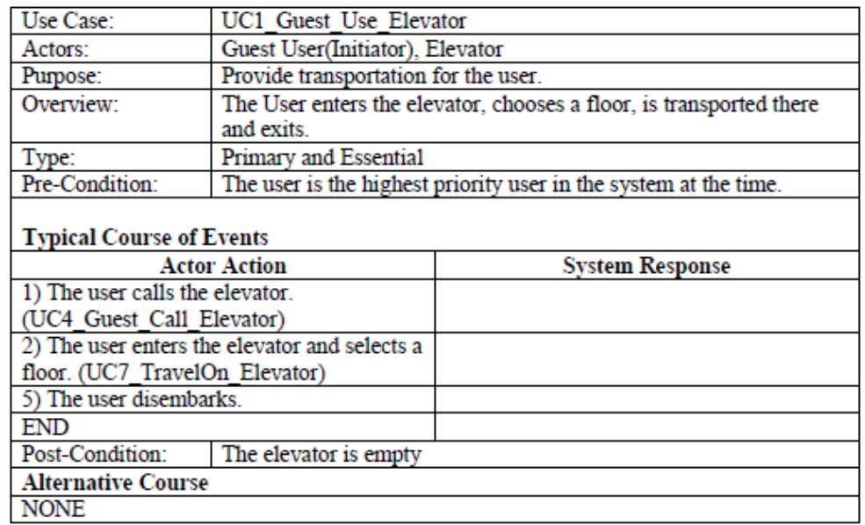

UC2 CardUser_Use_Elevator Use Case Scenario:
